**Correctness of Procedural Program:**

**Scenario: 1:**

**Input : 1, Expected output:0**

**QA Status: PASS**

**Output Screenshot:**

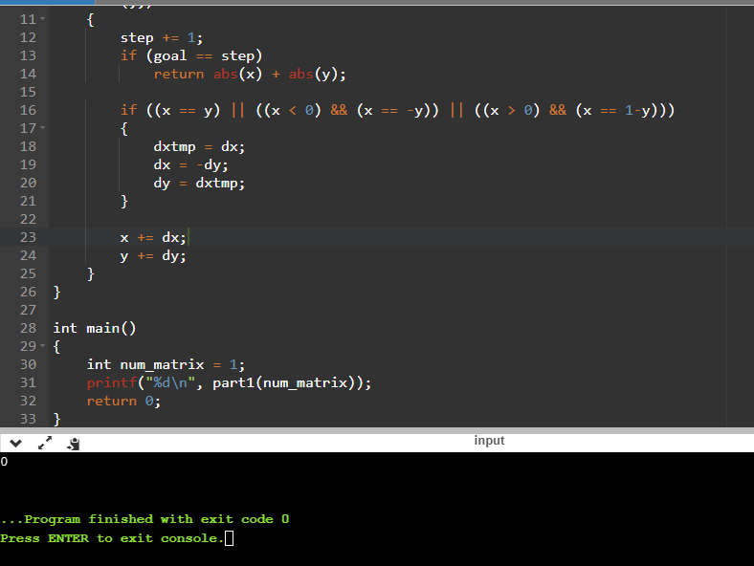

**Scenario: 2:**

**Input : 12, Expected output: 3**

**QA Status: PASS**

**Output Screenshot:**

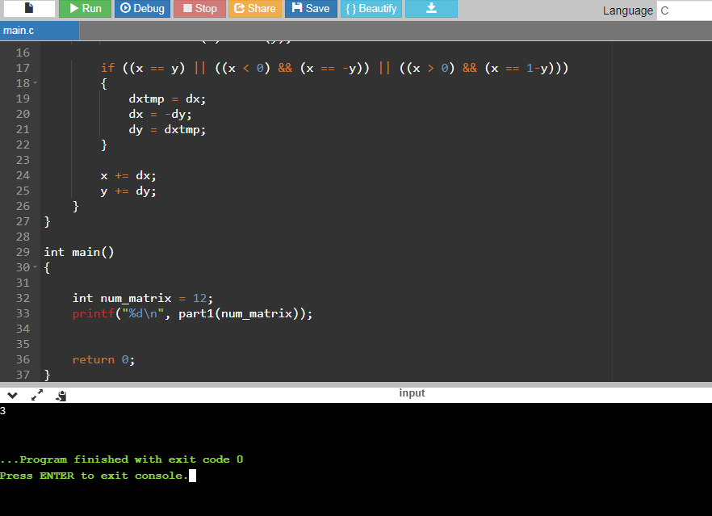

**Scenario: 3**

**Input : 23, Expected output:2**

**QA Status: PASS**

**Output Screenshot:**

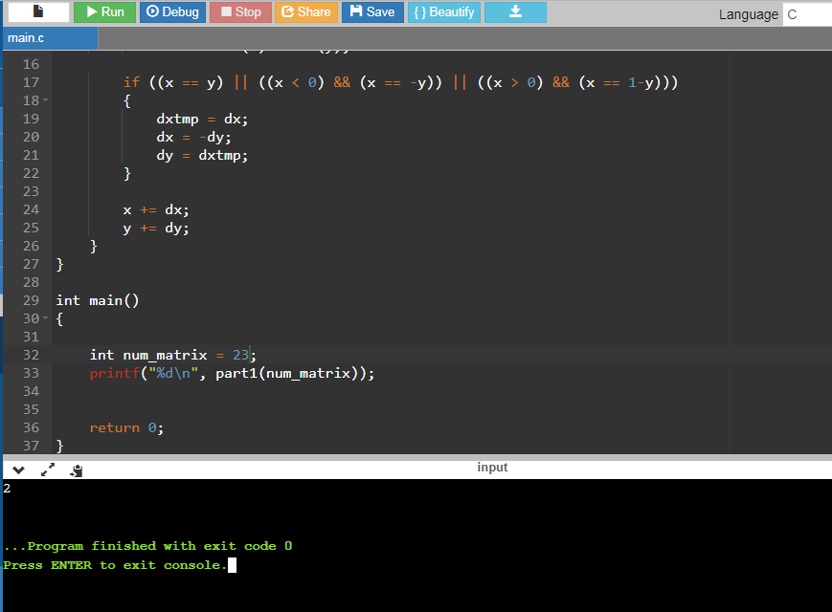

**Scenario: 4**

**Input : 1024, Expected output: 31**

**QA Status: PASS**

**Output Screenshot:**

